Rate My Slumlord

Sprint Review Report
Sprint 2
Version 1.3
07/09/2019

Matthew Gabrin, JP Held, Ryan Gabrin
Software Engineer

Prepared for
CS 1530 Software Engineering
Summer 2019
University of Pittsburgh

Revision History

Date | Description | Author | Comments
06/29/2019 | Version 1.1 | Gabrin, Gabrin, Held | Initial Revision
07/01/2019 | Version 1.2 | Gabrin, Gabrin, Held | Detail added to Specific Goals, Analytics charts added.
07/05/2019 | Version 1.3 | Gabrin, Gabrin, Held | Burndown and Velocity charts added, conclusion written, final changes made to Specific Goals stories.

Document Approval

The following Software Requirements Specification has been accepted and approved by the following:
Signature | Printed Name | Title | Date
 | Ryan Gabrin | Software Eng. | 07/09/2019
 | Matthew Gabrin | Software Eng. | 07/09/2019
 | John Held | Software Eng. | 07/09/2019

Table of Contents

Revision History ii
Document Approval ii
1. Introduction 1
2. Specific Goals 1
3. AnalTICS 6
4. CONCLUSION 7

1. Introduction
Sprint 2 focused mainly on developing the front-end graphical user interface (GUI) for the web application using REACT and JavaScript. With the database generated and in place, our team felt as though developing the front-end components of the system next would be the most useful; with this order, all development on the back-end to connect the GUI and database together in Sprint 3 will be done with both components in mind. This will hopefully result in less code-refactoring once the API required is initially generated and will increase the ease of development through providing a visual feedback system to judge test results on. Overall, a total of 9 stories and 36 points were planned for Sprint 2, and of that __ stories and __ story points were completed as anticipated. Up to this point, the project has a fully established database and complete GUI, which once connected with an API will allow the user to use the application with ease.
Overall, this sprint was difficult in that the REACT framework provides a less intuitive design capability than standard JavaScript/HTML through the use of CSS. With REACT, a developer is forced to use JavaFX to design the page, which can seem limited in its capabilities at first and presents a learning curve of its own in the beginning. Once the first page was developed, though, the process sped up immensely as all subsequent pages were modeled after the first to ensure a cohesive and consistent user experience along with a professional visual appeal for the application itself. Ultimately, all necessary pages have been given the necessary input/output fields, page connections, and styling conventions required for our final product’s implementation. Looking forward, the project’s next phase will be focused on back-end API application development aimed at connecting the database and GUI as described above, providing us with a fully-functional system as designed and desired.

2. Specific Goals
Below are all stories assigned to Sprint 2 with further clarification regarding their individual progress and purpose.

2.1 Story Name & Number
React – Login Page – Story 2.1.1
2.1.1 Story Description:
The goal of this story was ultimately to generate a login page for users to be accessed when a moderator or administrator would like to gain the necessary privileges to carry out their desired actions. This will be crucial to ensure that no un-qualified users gain higher access to the system components than they are supposed to have.
2.1.2 Story Acceptance Criterion
This story will be considered complete when a user is able to access the login page through one of the links in the navigation bar, where they are presented with input fields for their username and password as well as a submit button to allow them to increase permissions as necessary.
2.1.3 Story Dependencies
This story is not dependent on any other stories.
2.1.4 Story Challenges
The challenge with this story was unfamiliarity with spring. Lots of documentation was read in order to form a working structure, so most of the time spent on this story was done reading instead of coding. In addition, setting up a node React project with ability to transpile newer Javascript, webpack to bundle, and Bootstrap for premade CSS is non-trivial, as any one misconfiguration could break the whole setup.
2.1.5 Story Assigned to
Matthew Gabrin
2.1.6 Story Points
3 points were assigned to this story.
2.1.7 Status: Completed or not
Completed

2.2 Story Name & Number
React – Add user review page – Story 2.1.2
2.2.1 Story Description:
The goal of this story was ultimately to generate a form with which the user will be able to input data pertaining to a specific landlord – and optionally tied to a specific property – that will ultimately be used to calculate the landlord’s rating (also known as their Slumlord Score).
2.2.2 Story Acceptance Criterion
This story will be considered complete when the link existing in the navigation bar guides the user to a page with all necessary input fields to apply ratings and tags to a landlord.
2.2.3 Story Dependencies
This story is dependent on Story 2.1.3, focused on setting up the individual Landlord pages to view a specific landlord’s statistics and reviews. This is due to the fact that each user-review is tied to a specific landlord, so they will first have to go through the Landlord page to add a review.
2.2.4 Story Challenges
Collecting the information needed to set up the relations proved to take the most amount of time. Learning about how PostgreSQL differs from other SQL based DBMSs also proved a slight challenge.
2.2.5 Story Assigned to
Matthew Gabrin
2.2.6 Story Points
5 points were assigned to this story.
2.2.7 Status: Completed or not
Completed

2.3 Story Name & Number
React – Landlord page – Story 2.1.3
2.3.1 Story Description:
This story focuses on generating the hub to display all information collected for a specific landlord, including their reviews, applied tags, and scores collected from all review data. This is important in that it is the main page of the system that will provide the user with full information on a given landlord as intended.
2.3.2 Story Acceptance Criterion
This story will be considered complete when a landlord’s page is able to be viewed, displaying either dummy data provided to the database prior to setting up the API or the “no data” edge case outputs built into the system to display when no information exists for a landlord.
2.3.3 Story Dependencies
This story is not dependent on any other stories.
2.3.4 Story Challenges
This story was difficult in that it was
2.3.5 Story Assigned to
Ryan Gabrin
2.3.6 Story Points
5 points were assigned to this story.
2.3.7 Status: Completed or not
Completed

2.4 Story Name & Number
React – Add styling to all pages, maintaining consistency – Story 2.1.4
2.4.1 Story Description:
This story focuses on generating a cohesive and consistent user experience through establishing styling conventions to be used on all pages throughout the website. The hope in doing this is that traversing and fully utilizing each page will be easier for the user once they gain familiarity with the system and also to increase the visual appeal of the application as a whole.
2.4.2 Story Acceptance Criterion
This story will be considered complete when each page of the site utilizes consistent colors, fonts, sizes, spacing, and layout while still having the specified functionality of the individual page.
2.4.3 Story Dependencies
This story is dependent upon Story 2.1.1, creating the login page, 2.1.2, creating the add review page, 2.1.3, creating the landlord page, and 2.1.6, creating the tenant login page.
2.4.4 Story Challenges
No challenges for this story.
2.4.5 Story Assigned to
Ryan Gabrin
2.4.6 Story Points
4 points were assigned to this story.
2.4.7 Status: Completed or not
Completed

2.5 Story Name & Number
Postgres – Database authentication – Story 2.1.5
2.5.1 Story Description:
This story focuses on generating safeguards to ensure that the database will be protected from unexpected or malicious data manipulation from an unauthorized user attempting to access the data through system processes.
2.5.2 Story Acceptance Criterion
This story will be considered complete when the PostgreSQL database is capable of maintaining data for reviews in connection with specified landlords and properties, safely sharing the data between tables as necessary without overlap of users.
2.5.3 Story Dependencies
This story is not dependent on any other stories.
2.5.4 Story Challenges
No major challenges for this story.
2.5.5 Story Assigned to
JP Held
2.5.6 Story Points
3 points were assigned to this story.
2.5.7 Status: Completed or not
Completed

2.6 Story Name & Number
React – Tenant laws page – Story 2.1.6
2.6.1 Story Description:
This story focuses on generating a hub for all potentially helpful information for new and current tenants in need of legal assistance or guidance. Here, potentially necessary documents and explanations of legal rights tenants possess in a lease will be accessible to help ensure landlords aren’t capable of takin advantage of their residents in the event of a disagreement or issue.
2.6.2 Story Acceptance Criterion
This story will be considered complete when the user is able to access a page via a link in the navigation bar where numerous links are located to either download documents or traverse to a new website containing specified information on a given law, topic, or issue.
2.6.3 Story Dependencies
This story is not dependent on any other stories.
2.6.4 Story Challenges
Ensuring that information was accurate was the foremost challenge.
2.6.5 Story Assigned to
JP Held
2.6.6 Story Points
6 points were assigned to this story.
2.6.7 Status: Completed or not
Completed

2.7 Story Name & Number
React – Build in edge-case pages– Story 2.1.7
2.7.1 Story Description:
This story will focus on generating edge-case output for all necessary pages; landlord, login, add review, home, and tenant laws. These edge-cases will notify the user of invalid or inaccessible data, such as searching for a landlord without any reviews in the system, and it will guide them through the process of resolving this issue, such as adding the first review for a landlord in the example provided.
2.7.2 Story Acceptance Criterion
This story will be considered complete when each of the pages can be accessed prior to a database connection being established with the REST API and each page contains a notification of some sort alerting the user of the inaccessibility of the data they are requesting.
2.7.3 Story Dependencies
This story is dependent upon Story 2.1.1, creating the login page, 2.1.2, creating the add review page, 2.1.3, creating the landlord page, and 2.1.6, creating the tenant login page.
2.7.4 Story Challenges
No challenges for this story.
2.7.5 Story Assigned to
Matthew Gabrin
2.7.6 Story Points
4 points were to this story.
2.7.7 Status: Completed or not
Completed

2.8 Story Name & Number
React – Add success notifications for each individual action/page – Story 2.1.8
2.8.1 Story Description:
This story will focus on generating pop-up notifications for each action that results in a data manipulation carried out on the system. For example, when a review is submit and will therefore influence the associated landlord’s scores, a pop-up at the top of the screen will flash for approximately 3 seconds notifying the user of the successful submission. Adding these will help to ensure the user understands what is going on with the system when they make adjustments and changes.
2.8.2 Story Acceptance Criterion
This story will be considered complete when
2.8.3 Story Dependencies
This story is dependent upon Story 2.1.1, creating the login page, 2.1.2, creating the add review page, 2.1.3, creating the landlord page, and 2.1.6, creating the tenant login page.
2.8.4 Story Challenges
No challenges for this story.
2.8.5 Story Assigned to
Ryan Gabrin
2.8.6 Story Points
4 points were assigned to this story.
2.8.7 Status: Completed or not
Completed

2.9 Story Name & Number
React – Add failure notifications – Story 1.1.9
2.9.1 Story Description:
This story will focus on adding negative notifications to each page when a system function is attempted and fails to make any changes to the database or cannot be carried out for whatever reason. This is crucial to the functionality if the system as it will ensure users know when their data is being properly transmitted or is failing to go through, at which point they will have a better understanding of how and when to contact a system moderator/administrator to look into the issue.
2.9.2 Story Acceptance Criterion
This story will be considered complete when the application is able to be run from the command line and, when they have provided the proper URL, the user is able to access the Rate My Slumlord site and immediately views the Rate My Slumlord homepage allowing them to start filtering landlords and input their criteria.
2.9.3 Story Dependencies
This story is dependent upon Story 2.1.1, creating the login page, 2.1.2, creating the add review page, 2.1.3, creating the landlord page, and 2.1.6, creating the tenant login page.
2.9.4 Story Challenges
The most difficult part about the home page is determining what we wanted to display to the user as they arrived to the web application. In addition, we needed to implement design and functionality of the page at the same time in the form of Bootstrap components and core functionality because leaving one out would add more technical debt for refactoring than just doing it all at once.
2.9.5 Story Assigned to
JP Held
2.9.6 Story Points
2 points were assigned to this story.
2.9.7 Status: Completed or not
Completed.

3. Analytics

3.1 Sprint/Product Burndown Chart

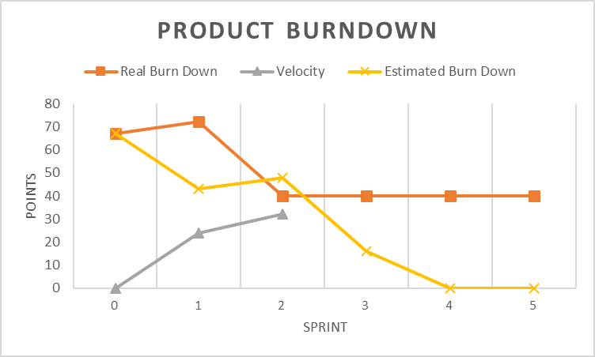

3.2 Sprint Velocity

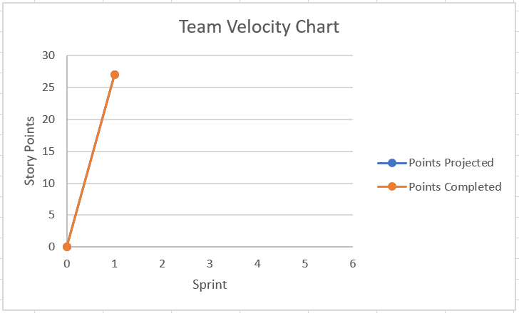

4. Conclusion
Ultimately, this Sprint focused on establishing the graphical user interface providing a smooth and cohesive user experience on the front-end of the application. All pages of the user-facing portion of the application were developed, styled, and set up to accept connections with the back-end API connecting the GUI and database with the hope that this will minimize the need to revise work done in previous sprints down the line. A clean and consistent design was applied across all pages to once again increase the ease of use and intuitive nature of the application once an end-user gets familiar with the initial style.
Looking ahead, Sprint 3 will focus more on the back-end Sprint/Java creation of an API. This is being done next so that the database and GUI can work with one another and final capabilities can be implemented and demonstrated for the application. Here, proper testing of the application will be able to be added using JUnit and Selenium to demonstrate the end-user experience when attempting the intended functions of the system. Overall, up to this point the project is on track to be completed within the anticipated timeframe, and the implementation of the SCRUM project management model was been very smooth to implement as well as helpful in keeping all team members organized.

